**Problem 15-1**

1. Consider the following sequence of numbers:

1, 2, 3, 4, 5, 1, 2, 3, 4, 5, 1, 2, 3, 4, 5, 1, 2, 3, 4, 5, 1, 2, 3, 4, 5, 1, 2, 3, 4, 5

Using the above numbers sequence, declare and initialize arrays of following sizes.

1. 2 x 15
2. 3 x 10
3. 6 x 5
4. Declare and initialize following 2D array with name tableOfNums.

|  |  |  |  |  |
| --- | --- | --- | --- | --- |
| 1 | 5 | 2 | 9 | -2 |
| -5 | 10 | 5 | 66 | 1 |
| 0 | 0 | 56 | 6 | 7 |
| 89 | -15 | -11 | 0 | 25 |

1. Complete following tasks about 2D arrays usage.
2. Print last element of array in problem 2
3. Print 3rd row of array in problem 2 **WITHOUT** **USING** loop.
4. Print 3rd row of array in problem 2 **USING** loop.
5. Print last column of array in problem 2 **USING** loop.
6. Try following statements/task. Does your program run or produce error? Why?
7. int arr[][] = {3,3,3,3,3,2};
8. int arr[2][] = {3, 3, 2, 1, 2, 3};
9. int arr[][2] = {3, 3, 2, 1, 2, 3};
10. Declare an unsized array with following values.

|  |  |  |  |
| --- | --- | --- | --- |
| 1 | 5 | -5 | 1 |
| 2 | 5 | 7 | 9 |

1. Initialize a 2x3 array named myArray with values given in (ii) using individual elements assignment. (The use of array initializer list is not allowed here)

**Program 15-2**

**Program Name:** Sum the elements of a 2 dimensional array

**Program Purpose:** Using multiple-subscripted (2 dimensional) array along with nested loop

**Problem Statement:** Write a program which declares a 2D array of size 3x3. The values of the array are input by the user at run-time (see sample output). After inputting the array values, show the sum of all the elements in the array.

**Hint:** Outer loop controls rows counter, inner loop controls columns counter. The contents of array are accessed inside inner loop.

**Sample Output:**

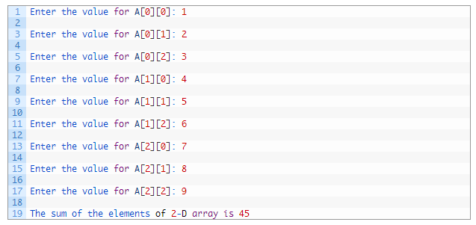

**Problem 15-3**

**Program Name:** Sum 2 matrices using nested loops

**Program Purpose:** Using multiple-subscripted (2 dimensional) array along with nested loop

**Problem Statement:** Write a program which declares 2 arrays of size 3x3. Each of these array represent a matrix containing following values.

Matrix 1:

Matrix 1:

Write down a program to compute another matrix that is sum of the two above matrices. Finally, display the summation matrix.

**Hint:** Declare another matrix of the same size. Compute sum of element at each position of the input matrices and store at corresponding position in the third matrix. The sum will be computed inside a nested loop. Outer loop controls rows counter, inner loop controls columns counter. The contents of matrices (all three matrices) are accessed inside the inner loop. The matrix printing will also be performed in nested loop. Use separate nested loop for this to avoid confusion.

**Sample Output:**

